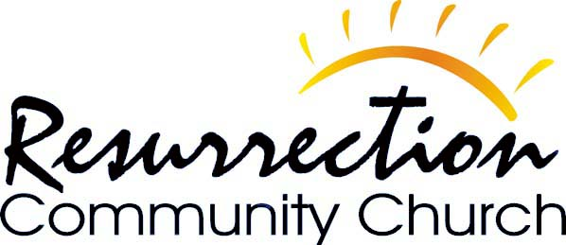
Feeding Souls Ministry
“A Church Called to Make a Difference”

1325 East Main Street – P. O. Box 46 – Albemarle, NC 28002 – (704) 982-5433

Matthew 25:35

For I was hungry and you gave me something to eat,

I was thirsty and you gave me something to drink,

I was a stranger and you invited me in,

Support Letter of Agreement
RCC Feeding Souls Ministry
THANK YOU for taking the first step toward becoming a financial supporter of Feeding Souls Ministry. We appreciate your generous giving to help us to continue to be a WELL OF SUPPLY to those in our surrounding communities near and far. The funds will be disbursed accordingly to meet the needs of the ministry.
Please sign this document in agreement with the amount of your monthly donations.
FIRST AND LAST NAME:

EMAIL:

PHONE NUMBER:

MONTHLY AMOUNT:

DATE SIGNED:

Please send all monetary gifts to Resurrection Community Church Feeding Souls Ministry through our church cash app $rccalbemarle2. Please state that the funds are for RCC Feeding Souls Ministry. You may also give in person by visitation or by attending one of our services here at RCC.
Your email will be used to keep you informed of RCC Feeding Souls Ministry progeress
feedingsoulsministry@gmail.com * 980-208-8099
“A Church Called to Make a Difference”

